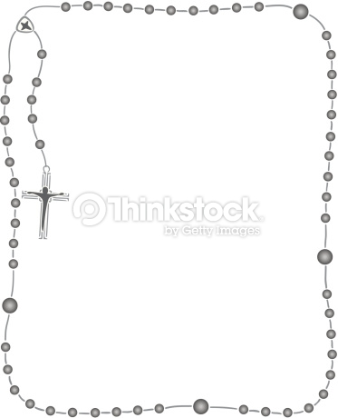

St Mary’s Catholic Primary School

Calcutta Road,
Tilbury,
Essex,
RM18 7QH
Tel: 01375 843254

Autumn Term Curriculum Reception Class

Class teacher:
Miss Cook

Teaching Assistants:
Mrs Clarke
Ms Osas

Some useful information:
Our topics this term are:
Autumn 1 - Me and My community
Autumn 2 - Traditional Tales

P.E
Our PE lessons this term will be on Tuesdays & Fridays. Children are required to attend school in their PE kit on PE days. PE kit as follows:
- Plain white polo shirt. Should parents wish to purchase with school logo, these are available from the school uniform providers.
- Plain navy (non-branded) shorts or skort.
- White socks (not tights)
- Navy school tracksuits available from our uniform providers or plain navy non-branded joggers and plain navy round next sweatshirt (no hoodies, no zipped jackets)
- Black trainers (please note children need to be able to tie their own laces if wearing trainers with laces!)
- NO jewellery for PE.

Reading
Please read with your child every evening for at least 10 minutes per day. You can log this with a comment in their reading diary.

I’m really looking forward to working together to ensure your child has a happy and successful start to the year. Your support makes a big difference, and I’m excited for all the learning and growth ahead!

Kind regards,

Miss Cook

Respect Ourselves, Respect Others, Respect our School, Love God
Literacy:
This term in Reception we will be:
- Writing our names and segmenting words for spelling
- Sequencing and retelling stories
- Learning and applying new vocabulary.
- Writing cards and letters
- Exploring features of different texts

Mathematics: Number/Numerical Patterns:
The children will be learning to:
- Recognise, describe and create patterns using shape, colour and numbers
- Recognise and write numerals 0-6
- Count and represent the numbers 0-6
- Compare numbers using the vocabulary of more than/less than
- Understand number sentences to begin to add and subtract objects

Understanding the World:
The children will be:
- Learning about similarities and differences between families
- Using their senses to explore and compare natural and urban environments
- Look at maps of the world, United Kingdom and the local area and create their own maps.
- Learning about celebrations in different cultural communities such as Christmas, Bonfire night and Diwali

Expressive Arts and Design:
The children will be working on:
- Experimenting with a variety of artistic processes such as collage, painting and drawing.
- Creating their own art, using different materials, tools and techniques to explore texture.
- Performing in a range of dramatic styles; roleplay, puppet shows and freeze frames.
- Singing a variety of familiar songs
- Using instruments to play along to familiar songs
Religious Education
The RE topics for Autumn are Creation and Covenant and Prophecy and Promise.
Within Religious Education we will be learning about:
- God’s creations, including us
- Looking after myself and God’s world
- How we are welcomed into God’s family through Baptism
- The Nativity
- Celebrations at Christmas

Personal, Social and Emotional Development:
This term we will be learning about:
- What makes us unique?
- How can we care for ourselves, others our world?
- How to stay healthy

Physical Development:
We will be:
- Developing gross motor skills and cooperation through games.
- Progressing our balancing, jumping and movement in gymnastics.
- Developing our dexterity with fine motor skills activities

Communication and Language
This term in Reception we will be:
- Engaging in conversations about myself, my experiences and familiar stories.
- Using partner talk to discuss our thoughts and feelings about a text.
- Begin to retell stories using new vocabulary
- Identifying the differences between fiction and non-fiction texts
- Anticipating events, speech and characters emotions in a text.

