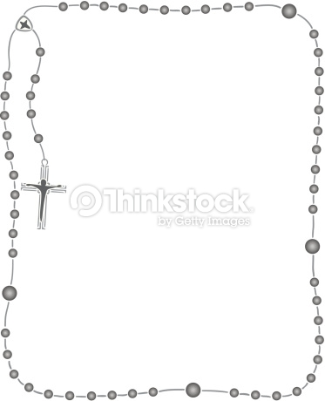

Some useful information:

P.E:
Our PE lessons this term will be on Monday and Friday. Children will wear PE kit to school on their PE day.
- PE kit is as follows:
- Plain white polo shirt. Should parents wish to purchase with school logo, these are available from the school uniform providers.
- Plain navy (non-branded) shorts or skort.
- White socks (not tights)
- Navy school tracksuits available from our uniform providers or plain navy non-branded joggers and plain navy round next sweatshirt (no hoodies, no zipped jackets)
- Black trainers (please note children need to be able to tie their own laces if wearing trainers with laces!)
- NO jewellery for PE.

Reading:
We encourage all children to read at home every day for at least 10 minutes after school. To help deepen their understanding and enjoyment of reading, we kindly ask that they write at least one sentence in their reading diary about what they have read.

Additionally, we would appreciate it if an adult could sign the diary each day to acknowledge and support their reading efforts.

To support your child’s reading development, Miss O’Sullivan or year 2 staff member will check reading diaries daily. We suggest that you talk with your child about what they’ve read e.g. “How do you think the character feels?” or “What do the pictures tell you about the story?” can really help build their comprehension skills.

Homework:
Children will receive ten spellings as homework on Mondays and will be tested the following Monday. Times Table Rockstars should be played for a minimum of 15 minutes per day to improve their multiplication recall.
Creative curriculum homework provides a selection of learning opportunities to enhance your child’s understanding of our class learning across a range of subjects. Children must complete 6 activities within the time frame.

Please check the class page on the school website for links to useful educational websites.

I’m really looking forward to working together to ensure your child has a happy and successful start to the year. Your support makes a big difference, and I’m excited for all the learning and growth ahead!

Kind regards,

Miss O’Sullivan
St Mary’s Catholic Primary School
Calcutta Road,
Tilbury,
Essex,
RM18 7QH
Tel: 01375 843254

Autumn Term Curriculum
For Year 2

Class teacher:
Miss O’Sullivan

Teaching Assistants:
Mrs Cox
Mrs Miccoli
Mrs Hyde
Respect Ourselves, Respect Others, Respect our School, Love God
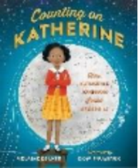
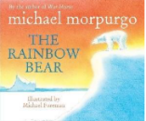
Geography:
Would you prefer to live in a hot or cold place?
- Locating all the world’s seven continents on a world map.
- Describing and beginning to explain some key similarities between their local area and a small area of a contrasting non-European country.
- Describing and beginning to explain some key differences between their local area and a small area of a contrasting non-European country.

History:
How was school different in the past?
- Knowing where people/events studied fit into a chronological framework.
- Recognising some things which have changed/stayed the same as the past.
- Identifying simple reasons for changes.

Computing:
- Computing systems and networks
Identifying what a computer is by learning how inputs and outputs work, how computers are used in the wider world and designing their own computerised invention.
- Developing an understanding of; what algorithms are, how to program them and how they can be developed to be more efficient, introduction of loops.
Art:
Art through different lenses
This unit explores drawing techniques, cultural appreciation, and composition through the lens of Kenyan art and wildlife. Pupils will build skills from mark-making to creating final pieces that combine animal forms with traditional Kenyan patterns.
D&T:
Cooking & Nutrition
Pupils will explore what makes a balanced diet by tasting ingredients from different food groups. They’ll then design a wrap that includes a healthy mix of protein, vegetables, and dairy.

P.E:
Children will develop ball handling and hand-eye coordination by practising with accuracy, confidence, and control through a variety of games and activities.
Music:
The children will be given the opportunity to:
Focus around: Hands, Feet Heart & Nativity preparation!
We will explain how sections of music can sound the same or different. An integrated approach to music where games, the dimensions of music (pulse, rhythm, pitch etc), singing and playing instruments are all linked.
R.E:
Our topics this term is Branch 1 – Creation and Covenant and Branch 2 – Prophecy and promise.
- The story of Noah and the concept of covenant as a promise between God and humanity.
- In the lead-up to the birth of Jesus, helping pupils understand how biblical figures prepared for and responded to God's message.

English:
Key texts:
The Rainbow Bear

Counting on Katherine

Writing focuses:
To inform: Newspaper report
To entertain: Narratives
To inform: Fact file

Mathematics:
Numbers within 100
- Read, write, represent, partition, compare and order numbers to 100
Addition and subtraction of 2-digit numbers
- Represent and explain addition and subtraction of two 2-digit numbers.
Addition and subtraction word problems
- Introduction to bar models as a representation
Measures: Length
- Draw and measure lengths in centimetres
Graphs
- Represent and interpret: pictograms, block diagrams, tables and tally charts.
Multiplication & Division
- Explore multiplication and division through arrays

Science:
Animal needs for survival
Find out about and describe the basic needs of animals, including humans, for survival (water, food and air).

Humans
Describe the importance for humans of exercise, eating the right amounts of different types of food, and hygiene.

Material Monsters
Children will learn to identify and compare the suitability of a variety of everyday materials, including wood, metal, plastic, glass, brick, rock, paper and cardboard for particular use.

Move it!
Children will find out how the shapes of solid objects made from some materials can be changed by squashing, bending, twisting and stretching.

Throughout the topics children will learn to:
- Observe closely
- Perform simple tests
- Identify and classify

