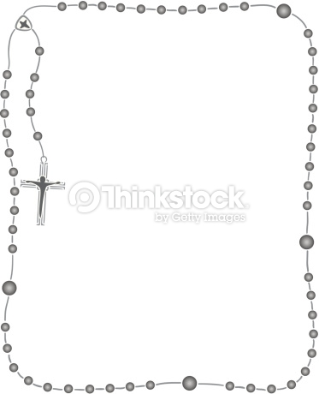

Some useful information:
P.E & Dance:
Our PE lessons this term will be on Monday and Friday. Children will wear PE kit to school on their PE day.
PE kit is as follows:
- Plain white polo shirt. Should parents wish to purchase with school logo, these are available from the school uniform providers.
- Plain navy (non-branded) shorts or skort.
- White socks (not tights)
- Navy school tracksuits available from our uniform providers or plain navy non-branded joggers and plain navy round next sweatshirt (no hoodies, no zipped jackets)
- Black trainers (please note children need to be able to tie their own laces if wearing trainers with laces!)
- NO jewellery for PE.

Reading:
Children are to read at home every day after school for a minimum of 15 minutes. Children will be provided with a schoolbook; however, they can also read a book from home, the library, a magazine, etc.
Remember to ask your child questions about the texts that they are reading, as this is vital in developing their literacy and comprehension skills. E.g. Why did ____ act like that? How are they feeling? What was your favourite part? Why? Predict what happens next. Why do you think this?

Homework:
Children will receive ten spellings as homework on Mondays and will be tested the following Monday. Times Table Rockstars should be played for a minimum of 15 minutes per day to improve their multiplication recall.
Creative curriculum homework provides a selection of learning opportunities to enhance your child’s understanding of our class learning across a range of subjects. Children must complete 6 activities within the time frame.

If you have any questions or concerns throughout the year, you can grab me at home time or contact the office to arrange a time to speak.

Looking forward to a fun year with a lot of learning!
Kind regards,
Miss Beauchamp.
St Mary’s Catholic Primary School

Calcutta Road,
Tilbury,
Essex,
RM18 7QH
Tel: 01375 843254

Autumn Term Curriculum
For Year 4

Class teacher:
Miss Beauchamp

Teaching Assistants:
Mrs Wilkes
Respect Ourselves, Respect Others, Respect our School, Love God
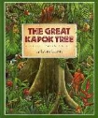
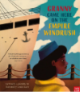
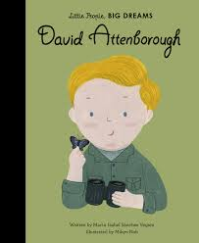
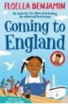
Geography:
Why are rainforests important?
Developing an understanding of biomes, ecosystems & tropics; discussing the global human impact of the Amazon; and carrying out fieldwork to compare two types of forest.

The children will be learning more about:
- Where in the world are rainforests?
- What is the Amazon rainforest like?
- Who lives in the rainforest?
- How are rainforests changing?
- How is our local woodland used?

History:
HMT Empire Windrush
The children will be learning more about:
- The history of the Windrush
- Who the Windrush generation are.
- Where the Windrush generation are today.
- The impact that the Windrush generation has had on Britain.
- How Windrush is celebrated.

Computing:
Collaborative Learning
- The children will be working collaboratively in a responsible & considerate way as well as looking at a range of collaborative tools.

Further coding with Scratch
- The children will be learning the basics of programming in Scratch, children will create a simple script, use decomposition & understand what variables are.

Art:
Rainforests - colour
- Mix to match tints, tones and shades in existing works.
- Mix and use, tints, tones and shades to apply to work.
- Use paints and chalk pastels
- Key artists: Ruth Daniels, Romero Britto

D&T
Food – adapting a recipe
- Follow a recipe, with some support.
- Describe some of the features of a biscuit based on taste, smell, texture and appearance.
- Adapt a recipe by adding extra ingredients to it.
- Plan a biscuit recipe within a budget.

P.E:
The children will learn to:
- Invasion games.
- Improve their basic skills.
- Games and gymnastics

Music:
Musical Spotlight: Musical Structures
Social Question: How Does Music Bring Us Together?
Look for patterns in the sections of music and songs within this unit. Verses and choruses can repeat or alternate and these provide structure in music.

Musical Spotlight: Exploring Feelings When You Play
Social Question: How Does Music Connect Us with Our Past?
Explore how special effects in music can make the words we sing more meaningful. The sounds that we hear in music can also help to communicate specific moods.
R.E:
- Branch 1: Creation & Covenant
In this branch, pupils will encounter the God who creates and calls a people. They will explore revelation of the Christian belief that all that comes from God, the Creation accounts in Genesis, and scientific explanations of the process of Creation, the call of God and his covenantal relationship with his people first through Abraham and Moses, then through the narrative of the Old Testament.
- Branch 2: Prophecy & Promise
In this branch, pupils will encounter the God who creates and calls a people. They will explore revelation of the Christian belief that all that comes from God, the Creation accounts in Genesis, and scientific explanations of the process of Creation. They will explore the call of God and his covenantal relationship with his people first through Abraham and Moses, then through the narrative of the Old Testament.

English:
Key Texts:
- The Great Kapok Tree
- Little People, Big Dreams
- Granny came here on the Empire Windrush
- Coming to England

Writing focus:
To persuade -Letter
To Inform – Explanation, diary entry
To entertain - Poetry (Tanka, Narrative)

Grammar focus:
- Ready to write
- Pronouns
- Fronted adverbials

Mathematics:
Reasoning with large numbers
- 4-digit place value. Read, write, represent, order and compare
- Find 10, 100 or 1000 more or less
- Round numbers to the nearest 10, 100 or 1000

Addition and subtraction
- Select appropriate strategies to add and subtract
- Illustrate and explain appropriate addition and subtraction strategies including column method with regrouping

Multiplication and division
- Identify and explore patterns in multiplication tables including 7 and 9
- Distributive property including multiplying three 1-digit numbers
- Mental multiplication and division strategies using place value and known and derived facts
- Short multiplication

Discrete and continuous data
- Read, interpret and construct pictograms, bar charts and time graphs
- Compare tables, pictograms and bar charts

Science:
- Group and Classify Living Things
Group animals and plants, identify vertebrates and invertebrates, use classification keys for animals and plants.
- Data Collection
Collect data from local environment, analyse data collected.
- States of Matter
Explore solids, liquids and gases, think differently about solids, liquids and gases, change states of matter, plan and investigate temperature changes, explore the water cycle, plan, investigate and evaluate an evaporation experiment.

